[How to Troubleshoot Power Supply Issues for PCs](http://helpdeskgeek.com/how-to/troubleshoot-pc-laptop-power-supply-issues/" \o "Permanent Link to How to Troubleshoot Power Supply Issues for PCs)

June 2nd, 2009 by Ben Carigtan | File in: [How-To](http://helpdeskgeek.com/category/how-to/)

Power supply failure or “no power” problems are encountered when the system does not respond or does not power up after pressing the power button. This is caused by the following

· Defective power source or low voltage

· Loose cable connections

· Improper motherboard lead connection

· Power supply failure

· Mother board failure

**Defective Power Source or Low Voltage**

If the system does not power up first thing to check in your Power source, this includes the power outlet, AVR, UPS. The simplest way to check the power from a power outlet is to plug-in a working electronics device, if the device power up then you can say that power is present. For AVR’s and UPS you can check the LED of these devices if it is lit. In the case of low voltage, you will need a voltmeter to measure the outpu voltage on the power outlet.

**Loose Cable Connections**

Sometimes the PC won’t turn on because of loose cable connections. Check the power cable if it is firmly attached to the power supply of the computer and to the power outlet or power source.

**Improper Motherboard Lead Connection**

Check the motherboard manual for the proper connections of the leads from the computer casing.

**Power Supply Failure**

If the power source and cables are ok and the system still does not power up. The problem might be caused by a defective power supply. These maybe caused by a defective hardware or power supply connector has a loose connection to the mother board. You can reinsert the power supply connector to the mother board or replace the power supply to check if this is defective. Another trick that I learned from experience

**Mother Board Failure**

After replacing the power supply and the system still does not power up then the problem may be caused by the mother board or the power connector of the mother board.

Refer to the flow chart below for a more detailed troubleshooting guide for power issues on PC’s and laptops:

[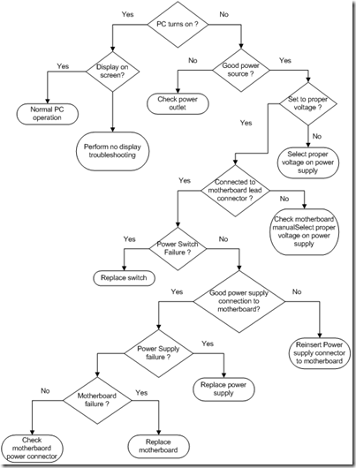](http://s.helpdeskgeek.com/wp-content/pictures/2009/06/image3.png?41ed4f)[[](http://s.helpdeskgeek.com/wp-content/pictures/2009/06/image3.png?41ed4f)<img style="border-bottom: 0px; border-left: 0px; display: block; float: none; margin-left: auto; border-top: 0px; margin-right: auto; border-right: 0px" src="http://s.helpdeskgeek.com/wp-content/pictures/2009/06/image-thumb3.png?41ed4f" border="0" alt="image" width="403" height="530" />](<img style=\"border-bottom: 0px; border-left: 0px; display: block; float: none; margin-left: auto; border-top: 0px; margin-right: auto; border-right: 0px\" src=\"http://s.helpdeskgeek.com/wp-content/pictures/2009/06/image-thumb3.png?41ed4f\" border=\"0\" alt=\"image\" width=\"403\" height=\"530\" />)